Eindopdracht_deel_2

Mohammed Al Hor

2022-10-16

library(MASS)  
library(car)

## Loading required package: carData

library(lmtest)

## Loading required package: zoo

##   
## Attaching package: 'zoo'

## The following objects are masked from 'package:base':  
##   
## as.Date, as.Date.numeric

library(HH)

## Loading required package: lattice

## Loading required package: grid

## Loading required package: latticeExtra

## Loading required package: multcomp

## Loading required package: mvtnorm

## Loading required package: survival

## Loading required package: TH.data

##   
## Attaching package: 'TH.data'

## The following object is masked from 'package:MASS':  
##   
## geyser

## Loading required package: gridExtra

##   
## Attaching package: 'HH'

## The following objects are masked from 'package:car':  
##   
## logit, vif

library(ggplot2)

##   
## Attaching package: 'ggplot2'

## The following object is masked from 'package:latticeExtra':  
##   
## layer

# setwd("~/Documents/Data-Science-Business-Analytics/Data")  
setwd("~/Data-Science-Business-Analytics/Data")  
college_statistics <- read.csv("college_statistics.csv", header = TRUE )  
# Rownames vullen met inhoud van de eerste kolom  
rownames(college_statistics) <- college_statistics[,1]  
# Verwijder eerste kolom  
college_statistics <- college_statistics[,-1]

4 (a) Voer eerst een test uit voor de hypothese dat het aantal aanmeldingen een normale verdeling volgt. Wat is je conclusie? Is deze conclusie van belang voor het verder modelleren van deze variabele?

summary(college_statistics$Apps)

## Min. 1st Qu. Median Mean 3rd Qu. Max.   
## 81 776 1558 3002 3624 48094

hist(college_statistics$Apps)

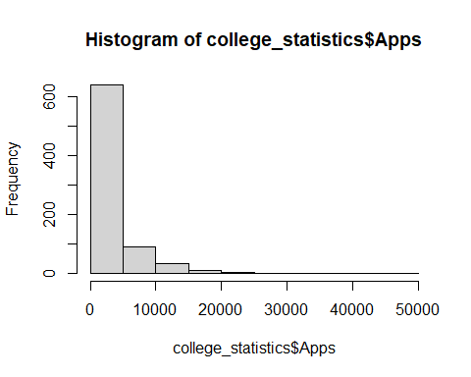

Both the histogram and qq plot indicate that this variable is not normally distributed (Positive skewness in histogram and not a straight line in the qqplot). Let put this to the test using the Shapiro-Wilk test for normality. H0: Apps is normally distributed Ha: Apps is not normally distributed

shapiro.test(college_statistics$Apps)

##   
## Shapiro-Wilk normality test  
##   
## data: college_statistics$Apps  
## W = 0.65408, p-value < 2.2e-16

The p-value is very small (less than 0.05), which means the null hypothesis can be rejected and the data is not normally distributed. However, because we have a decent sample size (777 observations) OLS remains a statistically sound method to use.

4 (b) Deel de data eerst op willekeurige manier op in een “estimation” en “test” sample. Neem 600 universiteiten in de estimation sample. Zorg ervoor dat deze opdeling reproduceerbaar is. Hint: de R-functies set.seed en sample kunnen hiervoor gebruikt worden.

set.seed(123)  
  
train_ind <- sample(seq_len(nrow(college_statistics)), size=600)  
  
college_statistics_est <- college_statistics[train_ind,]  
college_statistics_test <- college_statistics[-train_ind,]

First, we set the seed so the resulting dataframe can be reproduced. Then, we take a random sample of 600 observations. Using indexing we make an estimation dataframe and a test dataframe.

4 (c) Maak eerst een lineair model voor het aantal aanmeldingen. Gebruik hiervoor alleen de estimation sample.

fit1 <- lm(Apps ~ Private + Top10perc + Top25perc + F.Undergrad + P.Undergrad + Outstate + Room.Board + Books + Personal + PhD + Terminal +  
 S.F.Ratio + perc.alumni + Expend + Grad.Rate , data = college_statistics_est)  
summary(fit1)

##   
## Call:  
## lm(formula = Apps ~ Private + Top10perc + Top25perc + F.Undergrad +   
## P.Undergrad + Outstate + Room.Board + Books + Personal +   
## PhD + Terminal + S.F.Ratio + perc.alumni + Expend + Grad.Rate,   
## data = college_statistics_est)  
##   
## Residuals:  
## Min 1Q Median 3Q Max   
## -5663.8 -693.2 -105.4 500.2 6501.9   
##   
## Coefficients:  
## Estimate Std. Error t value Pr(>|t|)   
## (Intercept) -1.826e+03 6.449e+02 -2.831 0.004803 **   
## PrivateYes -7.248e+02 2.243e+02 -3.231 0.001303 **   
## Top10perc 2.875e+01 8.509e+00 3.379 0.000775 ***  
## Top25perc -8.082e+00 7.006e+00 -1.154 0.249097   
## F.Undergrad 6.271e-01 2.015e-02 31.117 < 2e-16 ***  
## P.Undergrad -1.620e-01 4.825e-02 -3.358 0.000837 ***  
## Outstate 4.967e-02 2.893e-02 1.717 0.086458 .   
## Room.Board 3.141e-01 7.245e-02 4.335 1.72e-05 ***  
## Books 3.526e-01 3.951e-01 0.892 0.372530   
## Personal -1.508e-01 1.016e-01 -1.485 0.138210   
## PhD -3.465e+00 7.471e+00 -0.464 0.642987   
## Terminal -7.226e+00 7.951e+00 -0.909 0.363806   
## S.F.Ratio 5.523e+00 2.019e+01 0.274 0.784464   
## perc.alumni -2.260e+01 6.405e+00 -3.529 0.000450 ***  
## Expend 9.556e-02 1.903e-02 5.023 6.78e-07 ***  
## Grad.Rate 1.916e+01 4.635e+00 4.133 4.11e-05 ***  
## ---  
## Signif. codes: 0 '***' 0.001 '**' 0.01 '*' 0.05 '.' 0.1 ' ' 1  
##   
## Residual standard error: 1435 on 584 degrees of freedom  
## Multiple R-squared: 0.8275, Adjusted R-squared: 0.8231   
## F-statistic: 186.8 on 15 and 584 DF, p-value: < 2.2e-16

Pretty straightforward, we use the lm() function to make a linear model. Accept and Enroll are omitted, these are obviously dependent on the amount of Apps.

4 (d) Pas backward elimination toe om het aantal variabelen terug te brengen.

We do the backwards step regression by using the stepAIC function and save the results in a list

backresults <- stepAIC(fit1, direction = "backward")

## Start: AIC=8738.76  
## Apps ~ Private + Top10perc + Top25perc + F.Undergrad + P.Undergrad +   
## Outstate + Room.Board + Books + Personal + PhD + Terminal +   
## S.F.Ratio + perc.alumni + Expend + Grad.Rate  
##   
## Df Sum of Sq RSS AIC  
## - S.F.Ratio 1 154253 1203281442 8736.8  
## - PhD 1 443098 1203570287 8737.0  
## - Books 1 1640768 1204767958 8737.6  
## - Terminal 1 1701690 1204828879 8737.6  
## - Top25perc 1 2742081 1205869270 8738.1  
## <none> 1203127189 8738.8  
## - Personal 1 4540164 1207667354 8739.0  
## - Outstate 1 6075495 1209202684 8739.8  
## - Private 1 21507032 1224634222 8747.4  
## - P.Undergrad 1 23225746 1226352935 8748.2  
## - Top10perc 1 23525430 1226652619 8748.4  
## - perc.alumni 1 25652521 1228779710 8749.4  
## - Grad.Rate 1 35187706 1238314895 8754.1  
## - Room.Board 1 38716903 1241844092 8755.8  
## - Expend 1 51972844 1255100033 8762.1  
## - F.Undergrad 1 1994744024 3197871214 9323.3  
##   
## Step: AIC=8736.83  
## Apps ~ Private + Top10perc + Top25perc + F.Undergrad + P.Undergrad +   
## Outstate + Room.Board + Books + Personal + PhD + Terminal +   
## perc.alumni + Expend + Grad.Rate  
##   
## Df Sum of Sq RSS AIC  
## - PhD 1 414401 1203695843 8735.0  
## - Books 1 1665478 1204946920 8735.7  
## - Terminal 1 1756106 1205037549 8735.7  
## - Top25perc 1 2726599 1206008042 8736.2  
## <none> 1203281442 8736.8  
## - Personal 1 4803821 1208085263 8737.2  
## - Outstate 1 5985897 1209267339 8737.8  
## - Private 1 22982373 1226263815 8746.2  
## - P.Undergrad 1 23276267 1226557709 8746.3  
## - Top10perc 1 23455551 1226736994 8746.4  
## - perc.alumni 1 26103898 1229385340 8747.7  
## - Grad.Rate 1 35075382 1238356824 8752.1  
## - Room.Board 1 38768998 1242050441 8753.9  
## - Expend 1 56786478 1260067921 8762.5  
## - F.Undergrad 1 2036163530 3239444972 9329.0  
##   
## Step: AIC=8735.04  
## Apps ~ Private + Top10perc + Top25perc + F.Undergrad + P.Undergrad +   
## Outstate + Room.Board + Books + Personal + Terminal + perc.alumni +   
## Expend + Grad.Rate  
##   
## Df Sum of Sq RSS AIC  
## - Books 1 1852894 1205548737 8734.0  
## - Top25perc 1 2804756 1206500599 8734.4  
## <none> 1203695843 8735.0  
## - Personal 1 5001124 1208696967 8735.5  
## - Outstate 1 5802887 1209498731 8735.9  
## - Terminal 1 7076378 1210772221 8736.6  
## - Private 1 22571491 1226267334 8744.2  
## - Top10perc 1 23124619 1226820462 8744.5  
## - P.Undergrad 1 23579052 1227274895 8744.7  
## - perc.alumni 1 25852700 1229548543 8745.8  
## - Grad.Rate 1 34675516 1238371359 8750.1  
## - Room.Board 1 38800594 1242496437 8752.1  
## - Expend 1 56425252 1260121095 8760.5  
## - F.Undergrad 1 2035841983 3239537826 9327.1  
##   
## Step: AIC=8733.96  
## Apps ~ Private + Top10perc + Top25perc + F.Undergrad + P.Undergrad +   
## Outstate + Room.Board + Personal + Terminal + perc.alumni +   
## Expend + Grad.Rate  
##   
## Df Sum of Sq RSS AIC  
## - Top25perc 1 2623869 1208172606 8733.3  
## <none> 1205548737 8734.0  
## - Personal 1 4114782 1209663519 8734.0  
## - Outstate 1 5679298 1211228035 8734.8  
## - Terminal 1 6729520 1212278257 8735.3  
## - Private 1 22284578 1227833315 8743.0  
## - P.Undergrad 1 23295180 1228843917 8743.4  
## - Top10perc 1 23469952 1229018689 8743.5  
## - perc.alumni 1 26709653 1232258390 8745.1  
## - Grad.Rate 1 34463261 1240011998 8748.9  
## - Room.Board 1 40214652 1245763389 8751.7  
## - Expend 1 56318465 1261867202 8759.4  
## - F.Undergrad 1 2035799498 3241348235 9325.4  
##   
## Step: AIC=8733.27  
## Apps ~ Private + Top10perc + F.Undergrad + P.Undergrad + Outstate +   
## Room.Board + Personal + Terminal + perc.alumni + Expend +   
## Grad.Rate  
##   
## Df Sum of Sq RSS AIC  
## <none> 1208172606 8733.3  
## - Personal 1 4300046 1212472653 8733.4  
## - Outstate 1 5360095 1213532702 8733.9  
## - Terminal 1 8813085 1216985691 8735.6  
## - Private 1 21815224 1229987830 8742.0  
## - P.Undergrad 1 23418800 1231591407 8742.8  
## - perc.alumni 1 28277317 1236449923 8745.1  
## - Grad.Rate 1 32910078 1241082685 8747.4  
## - Top10perc 1 35623933 1243796539 8748.7  
## - Room.Board 1 40153749 1248326355 8750.9  
## - Expend 1 66347441 1274520047 8763.3  
## - F.Undergrad 1 2033909292 3242081898 9323.5

Then, we record and evaluate the model selected by the backwards step regression method and assign this to fit1 using the following code:

backmodel <- backresults$call  
backmodel

## lm(formula = Apps ~ Private + Top10perc + F.Undergrad + P.Undergrad +   
## Outstate + Room.Board + Personal + Terminal + perc.alumni +   
## Expend + Grad.Rate, data = college_statistics_est)

# This line evaluates the 'code' of the model  
backmodel <- eval(backmodel)  
fit1 <- backmodel  
summary(fit1)

##   
## Call:  
## lm(formula = Apps ~ Private + Top10perc + F.Undergrad + P.Undergrad +   
## Outstate + Room.Board + Personal + Terminal + perc.alumni +   
## Expend + Grad.Rate, data = college_statistics_est)  
##   
## Residuals:  
## Min 1Q Median 3Q Max   
## -5662.7 -694.6 -103.6 526.2 6428.6   
##   
## Coefficients:  
## Estimate Std. Error t value Pr(>|t|)   
## (Intercept) -1.703e+03 4.608e+02 -3.697 0.000239 ***  
## PrivateYes -7.113e+02 2.183e+02 -3.258 0.001185 **   
## Top10perc 2.092e+01 5.024e+00 4.164 3.60e-05 ***  
## F.Undergrad 6.265e-01 1.991e-02 31.462 < 2e-16 ***  
## P.Undergrad -1.625e-01 4.813e-02 -3.376 0.000784 ***  
## Outstate 4.643e-02 2.874e-02 1.615 0.106817   
## Room.Board 3.190e-01 7.217e-02 4.421 1.17e-05 ***  
## Personal -1.431e-01 9.893e-02 -1.447 0.148530   
## Terminal -1.088e+01 5.254e+00 -2.071 0.038791 *   
## perc.alumni -2.352e+01 6.341e+00 -3.710 0.000227 ***  
## Expend 9.815e-02 1.727e-02 5.682 2.09e-08 ***  
## Grad.Rate 1.835e+01 4.585e+00 4.002 7.08e-05 ***  
## ---  
## Signif. codes: 0 '***' 0.001 '**' 0.01 '*' 0.05 '.' 0.1 ' ' 1  
##   
## Residual standard error: 1433 on 588 degrees of freedom  
## Multiple R-squared: 0.8268, Adjusted R-squared: 0.8236   
## F-statistic: 255.2 on 11 and 588 DF, p-value: < 2.2e-16

The formula for this model is as follows: formula = Apps ~ Private + Top10perc + F.Undergrad + P.Undergrad + Outstate + Room.Board + Personal + Terminal + perc.alumni + Expend + Grad.Rate

4 (e) Voer diverse toetsen uit om de aannamen van het lineaire model te testen.

Now that we have a model, we can start by testing some of the assumptions of this model. First, let’s take a look at the qqplot of this model.

Test for normality(A6) using qqplot:

qqPlot(fit1)

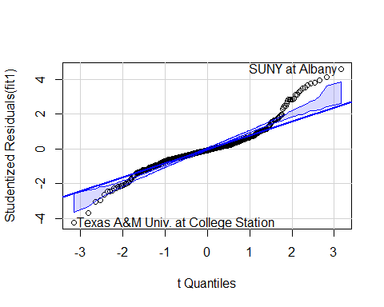

## Texas A&M Univ. at College Station SUNY at Albany   
## 488 550

shapiro.test(residuals(fit1))

##   
## Shapiro-Wilk normality test  
##   
## data: residuals(fit1)  
## W = 0.91962, p-value < 2.2e-16

A lot of the datapoints don’t fall along the reference line, which means we can assume non normality. We alo observe outliers for Texas A&M Univ. at College Station and SUNY at Albany. Furthermore, the Shpiro-Wilk test on the residuals provides us the evidence to reject normality (p-value is quite small, so we can reject the null hypothesis for normality).

Test for independence(A5) using the Durbin-Watson test.

durbinWatsonTest(fit1)

## lag Autocorrelation D-W Statistic p-value  
## 1 0.0359695 1.927191 0.414  
## Alternative hypothesis: rho != 0

No autocorrelation detected (p-value is 0.382), which makes sense when we take into account the data we have(not time series data).

Let’s check for linearity(A3) using component + residual plot

crPlots(fit1)

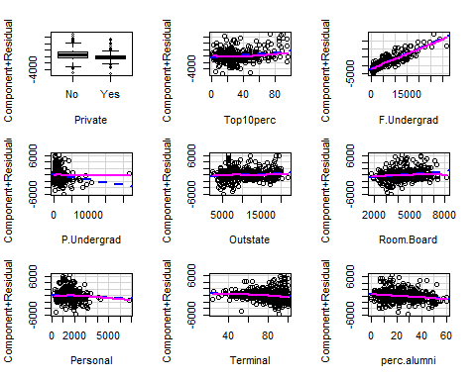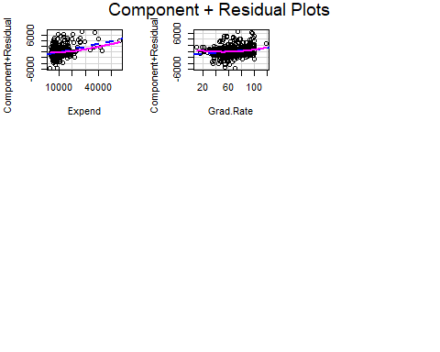

Looking at these plots, we observe some non-linearity (especially in Expend and Personal). Let’s put this to the test, using the the resettest from the lmtest package.

resettest(fit1, power=2)

##   
## RESET test  
##   
## data: fit1  
## RESET = 5.0481, df1 = 1, df2 = 587, p-value = 0.02502

H0: linear relation between x and y Ha: some nonlinearity

As we can see the p-value is quite small (<0.05) which means we can reject the null hypthesis and thus linearity.

Next, let’s take a look at Homoskedasticity(A4) using the Breusch-Pagan test:

ncvTest(fit1)

## Non-constant Variance Score Test   
## Variance formula: ~ fitted.values   
## Chisquare = 394.1075, Df = 1, p = < 2.22e-16

H0: constant variances (homoskedasticity) Ha: non-constant variances (heteroskedasticity)

We can reject H0 of homoskedasticity -> variances are not constant or heteroscedasticity is present.

We can also check for multicolinearity (A7) (No perfect linear relationship in X)

vif(fit1)

## PrivateYes Top10perc F.Undergrad P.Undergrad Outstate Room.Board   
## 2.784858 2.351514 2.419156 1.651071 3.898348 1.834423   
## Personal Terminal perc.alumni Expend Grad.Rate   
## 1.260313 1.753760 1.795078 2.401752 1.847167

None are larger than 4 (this is the rule of thumb), we can assume no multicolinearity.

Because OLS is quite sensitive to outliers, let’s do a quick outlier test.

outlierTest(fit1)

## rstudent unadjusted p-value Bonferroni p  
## SUNY at Albany 4.597908 5.2295e-06 0.0031377  
## Texas A&M Univ. at College Station -4.230119 2.7093e-05 0.0162560  
## University of Virginia 4.142904 3.9336e-05 0.0236020

As we previously saw in the qqplot there are some outliers, ‘SUNY at Albany’, ‘Texas A&M Univ. at College Station’ and ‘University of Virginia’.

4 (f) Maak vervolgens een model voor de logaritme van het aantal aanmeldingen (ook weer met backward elimination).

The steps for this are the same as for the previous model, thus I will not go into detail.

fit2 <- lm(log(Apps) ~ Private + Top10perc + Top25perc + F.Undergrad + P.Undergrad + Outstate + Room.Board + Books + Personal + PhD + Terminal +  
 S.F.Ratio + perc.alumni + Expend + Grad.Rate , data = college_statistics_est)  
summary(fit2)

##   
## Call:  
## lm(formula = log(Apps) ~ Private + Top10perc + Top25perc + F.Undergrad +   
## P.Undergrad + Outstate + Room.Board + Books + Personal +   
## PhD + Terminal + S.F.Ratio + perc.alumni + Expend + Grad.Rate,   
## data = college_statistics_est)  
##   
## Residuals:  
## Min 1Q Median 3Q Max   
## -2.17654 -0.33006 0.02374 0.36395 1.80192   
##   
## Coefficients:  
## Estimate Std. Error t value Pr(>|t|)   
## (Intercept) 4.341e+00 2.530e-01 17.159 < 2e-16 ***  
## PrivateYes -6.232e-01 8.798e-02 -7.083 4.08e-12 ***  
## Top10perc 1.088e-03 3.337e-03 0.326 0.74463   
## Top25perc 2.656e-03 2.748e-03 0.967 0.33416   
## F.Undergrad 1.131e-04 7.905e-06 14.311 < 2e-16 ***  
## P.Undergrad -4.220e-06 1.893e-05 -0.223 0.82365   
## Outstate 4.677e-05 1.135e-05 4.123 4.29e-05 ***  
## Room.Board 7.242e-05 2.842e-05 2.548 0.01108 *   
## Books 4.324e-04 1.550e-04 2.791 0.00543 **   
## Personal 5.496e-05 3.983e-05 1.380 0.16819   
## PhD 3.506e-03 2.930e-03 1.197 0.23198   
## Terminal 2.153e-03 3.119e-03 0.690 0.49035   
## S.F.Ratio 4.267e-02 7.917e-03 5.389 1.03e-07 ***  
## perc.alumni -7.010e-03 2.512e-03 -2.790 0.00544 **   
## Expend 2.990e-05 7.463e-06 4.006 6.97e-05 ***  
## Grad.Rate 1.039e-02 1.818e-03 5.714 1.76e-08 ***  
## ---  
## Signif. codes: 0 '***' 0.001 '**' 0.01 '*' 0.05 '.' 0.1 ' ' 1  
##   
## Residual standard error: 0.563 on 584 degrees of freedom  
## Multiple R-squared: 0.7157, Adjusted R-squared: 0.7084   
## F-statistic: 98.02 on 15 and 584 DF, p-value: < 2.2e-16

# Backwards step regression  
backresults <- stepAIC(fit2, direction = "backward")

## Start: AIC=-673.63  
## log(Apps) ~ Private + Top10perc + Top25perc + F.Undergrad + P.Undergrad +   
## Outstate + Room.Board + Books + Personal + PhD + Terminal +   
## S.F.Ratio + perc.alumni + Expend + Grad.Rate  
##   
## Df Sum of Sq RSS AIC  
## - P.Undergrad 1 0.016 185.11 -675.57  
## - Top10perc 1 0.034 185.13 -675.52  
## - Terminal 1 0.151 185.25 -675.14  
## - Top25perc 1 0.296 185.39 -674.67  
## - PhD 1 0.454 185.55 -674.16  
## - Personal 1 0.603 185.70 -673.67  
## <none> 185.10 -673.63  
## - Room.Board 1 2.058 187.16 -668.99  
## - perc.alumni 1 2.467 187.57 -667.68  
## - Books 1 2.468 187.57 -667.68  
## - Expend 1 5.086 190.19 -659.36  
## - Outstate 1 5.387 190.49 -658.41  
## - S.F.Ratio 1 9.206 194.30 -646.50  
## - Grad.Rate 1 10.347 195.44 -642.99  
## - Private 1 15.900 201.00 -626.18  
## - F.Undergrad 1 64.917 250.01 -495.24  
##   
## Step: AIC=-675.57  
## log(Apps) ~ Private + Top10perc + Top25perc + F.Undergrad + Outstate +   
## Room.Board + Books + Personal + PhD + Terminal + S.F.Ratio +   
## perc.alumni + Expend + Grad.Rate  
##   
## Df Sum of Sq RSS AIC  
## - Top10perc 1 0.038 185.15 -677.45  
## - Terminal 1 0.150 185.26 -677.09  
## - Top25perc 1 0.295 185.41 -676.62  
## - PhD 1 0.447 185.56 -676.13  
## - Personal 1 0.590 185.70 -675.67  
## <none> 185.11 -675.57  
## - Room.Board 1 2.043 187.16 -670.99  
## - Books 1 2.459 187.57 -669.66  
## - perc.alumni 1 2.464 187.58 -669.64  
## - Expend 1 5.074 190.19 -661.35  
## - Outstate 1 5.410 190.52 -660.29  
## - S.F.Ratio 1 9.217 194.33 -648.42  
## - Grad.Rate 1 10.651 195.76 -644.01  
## - Private 1 15.893 201.01 -628.15  
## - F.Undergrad 1 74.765 259.88 -474.03  
##   
## Step: AIC=-677.45  
## log(Apps) ~ Private + Top25perc + F.Undergrad + Outstate + Room.Board +   
## Books + Personal + PhD + Terminal + S.F.Ratio + perc.alumni +   
## Expend + Grad.Rate  
##   
## Df Sum of Sq RSS AIC  
## - Terminal 1 0.137 185.29 -679.01  
## - PhD 1 0.469 185.62 -677.93  
## - Personal 1 0.582 185.73 -677.57  
## <none> 185.15 -677.45  
## - Top25perc 1 1.368 186.52 -675.03  
## - Room.Board 1 2.022 187.18 -672.93  
## - perc.alumni 1 2.460 187.61 -671.53  
## - Books 1 2.480 187.63 -671.47  
## - Outstate 1 5.424 190.58 -662.13  
## - Expend 1 6.424 191.58 -658.99  
## - S.F.Ratio 1 9.197 194.35 -650.36  
## - Grad.Rate 1 10.743 195.90 -645.61  
## - Private 1 15.857 201.01 -630.15  
## - F.Undergrad 1 75.158 260.31 -475.03  
##   
## Step: AIC=-679.01  
## log(Apps) ~ Private + Top25perc + F.Undergrad + Outstate + Room.Board +   
## Books + Personal + PhD + S.F.Ratio + perc.alumni + Expend +   
## Grad.Rate  
##   
## Df Sum of Sq RSS AIC  
## - Personal 1 0.557 185.85 -679.21  
## <none> 185.29 -679.01  
## - Top25perc 1 1.410 186.70 -676.46  
## - PhD 1 2.004 187.29 -674.55  
## - Room.Board 1 2.166 187.46 -674.04  
## - perc.alumni 1 2.365 187.65 -673.40  
## - Books 1 2.636 187.93 -672.53  
## - Outstate 1 5.596 190.88 -663.16  
## - Expend 1 6.372 191.66 -660.72  
## - S.F.Ratio 1 9.111 194.40 -652.21  
## - Grad.Rate 1 10.611 195.90 -647.59  
## - Private 1 16.389 201.68 -630.15  
## - F.Undergrad 1 75.713 261.00 -475.44  
##   
## Step: AIC=-679.21  
## log(Apps) ~ Private + Top25perc + F.Undergrad + Outstate + Room.Board +   
## Books + PhD + S.F.Ratio + perc.alumni + Expend + Grad.Rate  
##   
## Df Sum of Sq RSS AIC  
## <none> 185.85 -679.21  
## - Top25perc 1 1.395 187.24 -676.72  
## - Room.Board 1 2.077 187.92 -674.54  
## - PhD 1 2.131 187.98 -674.37  
## - perc.alumni 1 2.577 188.42 -672.94  
## - Books 1 3.200 189.05 -670.96  
## - Outstate 1 5.273 191.12 -664.42  
## - Expend 1 6.548 192.40 -660.43  
## - S.F.Ratio 1 8.712 194.56 -653.72  
## - Grad.Rate 1 10.112 195.96 -649.42  
## - Private 1 16.243 202.09 -630.93  
## - F.Undergrad 1 82.162 268.01 -461.55

# Record the best model selected by the backwards method  
# This line takes the model specification as 'code'  
backmodel <- backresults$call  
backmodel

## lm(formula = log(Apps) ~ Private + Top25perc + F.Undergrad +   
## Outstate + Room.Board + Books + PhD + S.F.Ratio + perc.alumni +   
## Expend + Grad.Rate, data = college_statistics_est)

# This line evaluates the 'code' of the model  
backmodel <- eval(backmodel)  
summary(backmodel)

##   
## Call:  
## lm(formula = log(Apps) ~ Private + Top25perc + F.Undergrad +   
## Outstate + Room.Board + Books + PhD + S.F.Ratio + perc.alumni +   
## Expend + Grad.Rate, data = college_statistics_est)  
##   
## Residuals:  
## Min 1Q Median 3Q Max   
## -2.21420 -0.33085 0.02215 0.37221 1.76272   
##   
## Coefficients:  
## Estimate Std. Error t value Pr(>|t|)   
## (Intercept) 4.469e+00 2.226e-01 20.080 < 2e-16 ***  
## PrivateYes -6.243e-01 8.709e-02 -7.169 2.28e-12 ***  
## Top25perc 3.449e-03 1.642e-03 2.101 0.03607 *   
## F.Undergrad 1.149e-04 7.126e-06 16.123 < 2e-16 ***  
## Outstate 4.581e-05 1.122e-05 4.084 5.03e-05 ***  
## Room.Board 7.191e-05 2.805e-05 2.564 0.01061 *   
## Books 4.810e-04 1.512e-04 3.182 0.00154 **   
## PhD 5.110e-03 1.968e-03 2.596 0.00966 **   
## S.F.Ratio 4.117e-02 7.842e-03 5.250 2.12e-07 ***  
## perc.alumni -7.100e-03 2.486e-03 -2.856 0.00445 **   
## Expend 3.112e-05 6.837e-06 4.552 6.47e-06 ***  
## Grad.Rate 9.995e-03 1.767e-03 5.656 2.42e-08 ***  
## ---  
## Signif. codes: 0 '***' 0.001 '**' 0.01 '*' 0.05 '.' 0.1 ' ' 1  
##   
## Residual standard error: 0.5622 on 588 degrees of freedom  
## Multiple R-squared: 0.7146, Adjusted R-squared: 0.7092   
## F-statistic: 133.8 on 11 and 588 DF, p-value: < 2.2e-16

fit2 <- backmodel  
summary(fit2)

##   
## Call:  
## lm(formula = log(Apps) ~ Private + Top25perc + F.Undergrad +   
## Outstate + Room.Board + Books + PhD + S.F.Ratio + perc.alumni +   
## Expend + Grad.Rate, data = college_statistics_est)  
##   
## Residuals:  
## Min 1Q Median 3Q Max   
## -2.21420 -0.33085 0.02215 0.37221 1.76272   
##   
## Coefficients:  
## Estimate Std. Error t value Pr(>|t|)   
## (Intercept) 4.469e+00 2.226e-01 20.080 < 2e-16 ***  
## PrivateYes -6.243e-01 8.709e-02 -7.169 2.28e-12 ***  
## Top25perc 3.449e-03 1.642e-03 2.101 0.03607 *   
## F.Undergrad 1.149e-04 7.126e-06 16.123 < 2e-16 ***  
## Outstate 4.581e-05 1.122e-05 4.084 5.03e-05 ***  
## Room.Board 7.191e-05 2.805e-05 2.564 0.01061 *   
## Books 4.810e-04 1.512e-04 3.182 0.00154 **   
## PhD 5.110e-03 1.968e-03 2.596 0.00966 **   
## S.F.Ratio 4.117e-02 7.842e-03 5.250 2.12e-07 ***  
## perc.alumni -7.100e-03 2.486e-03 -2.856 0.00445 **   
## Expend 3.112e-05 6.837e-06 4.552 6.47e-06 ***  
## Grad.Rate 9.995e-03 1.767e-03 5.656 2.42e-08 ***  
## ---  
## Signif. codes: 0 '***' 0.001 '**' 0.01 '*' 0.05 '.' 0.1 ' ' 1  
##   
## Residual standard error: 0.5622 on 588 degrees of freedom  
## Multiple R-squared: 0.7146, Adjusted R-squared: 0.7092   
## F-statistic: 133.8 on 11 and 588 DF, p-value: < 2.2e-16

Different independent variables are selected by the backwards step regression when we use the log of Apps. formula = log(Apps) ~ Private + Top25perc + F.Undergrad + Outstate + Room.Board + Books + PhD + S.F.Ratio + perc.alumni + Expend + Grad.Rate, data = college_statistics_est

4 (g) Voer opnieuw de diverse toetsen uit om de aannamen van het model te testen.

Test for normality

qqPlot(fit2)

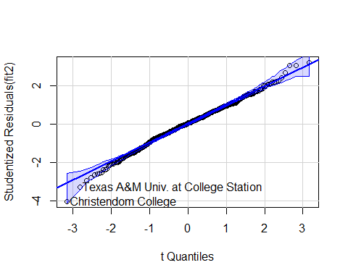

## Christendom College Texas A&M Univ. at College Station   
## 242 488

shapiro.test(residuals(fit2))

##   
## Shapiro-Wilk normality test  
##   
## data: residuals(fit2)  
## W = 0.99453, p-value = 0.03029

The data points fall along the reference line quite well compared to the previous model. We still see some outliers for ‘Christendom College’ and ‘Texas A&M Univ. at College Station’. A Shapiro-Wilk test for normality of the residuals provides us with evidence that the residuals are not normally distributed(null hypothesis can be rejected with p-value smaller than 0.05).

Test for independence using the Durbin-Watson test.

durbinWatsonTest(fit2)

## lag Autocorrelation D-W Statistic p-value  
## 1 0.06271588 1.873683 0.104  
## Alternative hypothesis: rho != 0

No autocorrelation detected (p-value is 0.122), which makes sense when we take into account the data we have(not time series data).

Let’s check for linearity(A3) using component + residual plot

crPlots(fit2)

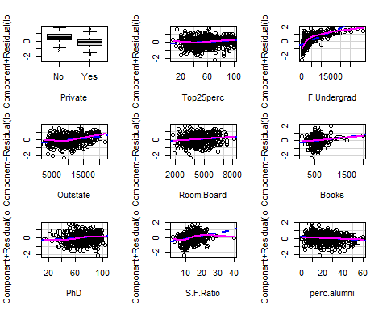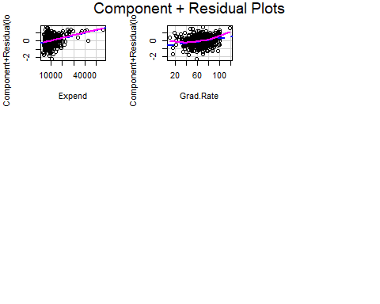

Looking at these plots, we observe more ‘non-linearity’ than in the previous mdoel. (especially in F.Undergrad, S.F.Ratio, Grad.Rate). Let’s put this to the test, using the the resettest from the lmtest package.

H0: linear relation between x and y Ha: some nonlinearity

resettest(fit2, power=2)

##   
## RESET test  
##   
## data: fit2  
## RESET = 84.075, df1 = 1, df2 = 587, p-value < 2.2e-16

As we can see the p-value is quite small (<0.05) which means we can reject the null hypthesis and thus linearity.

Next, let’s take a look at Homoskedasticity(A4) using the Breusch-Pagan test:

ncvTest(fit2)

## Non-constant Variance Score Test   
## Variance formula: ~ fitted.values   
## Chisquare = 1.550253, Df = 1, p = 0.2131

H0: constant variances (homoskedasticity) Ha: non-constant variances (heteroskedasticity) We fail to reject the null-hypothesis (p-value > 0.05), and thus can assume homoskedacticity is present.

A7 Multicolinearity (No perfect linear relationship in X)

vif(fit2)

## PrivateYes Top25perc F.Undergrad Outstate Room.Board Books   
## 2.881235 2.024971 2.014211 3.858887 1.801658 1.046697   
## PhD S.F.Ratio perc.alumni Expend Grad.Rate   
## 1.885400 1.887194 1.794143 2.446720 1.784017

None are larger than 4 (this is the rule of thumb), we can assume no multicolinearity.

Because OLS is quite sensitive to outliers, let’s do a quick outlier test.

outlierTest(fit2)

## rstudent unadjusted p-value Bonferroni p  
## Christendom College -4.035229 6.1767e-05 0.03706

As we previously saw in the qqplot we have one observation that was relatively far from the reference line;‘Christendom College’.

4 (h) Welk van de twee modellen heeft de voorkeur?

Looking at the previous test we performed on the two models we see that the log model has a better fit (qqplot), the variances are constant (homoskedacticity) and all the variables are significant. However, let’s compare these two models using ‘Goodness-of-fit Measures’. Akaike’s information criterion can be calculated using the AIC function in R. The smaller the AIC the better the fit of the model.

AIC(fit1,fit2)

## df AIC  
## fit1 13 10437.993  
## fit2 13 1025.521

We see that model 2 outperforms model 1, the log-likelihood value is much lower, 1025 for model 2 and 10437 for model 1. Therefore we pick model 2.

4 (i) Probeer het gekozen model nog verder te verbeteren: denk aan het toevoegen van transformaties van verklarende variabelen.

It is apparent, from the crPlot, that the relationship between the log(Apps) and the F.Undergrad variable is not linear. Let’s try to do a square root transformation on this variable and compare the models.

fit3 <- lm(formula = log(Apps) ~ Private + Top25perc + F.Undergrad + I(sqrt(F.Undergrad)) +  
 Outstate + Room.Board + Books + PhD + S.F.Ratio + perc.alumni +   
 Expend + Grad.Rate, data = college_statistics_est)

summary(fit3)

##   
## Call:  
## lm(formula = log(Apps) ~ Private + Top25perc + F.Undergrad +   
## I(sqrt(F.Undergrad)) + Outstate + Room.Board + Books + PhD +   
## S.F.Ratio + perc.alumni + Expend + Grad.Rate, data = college_statistics_est)  
##   
## Residuals:  
## Min 1Q Median 3Q Max   
## -2.39100 -0.24284 0.01382 0.26962 2.03651   
##   
## Coefficients:  
## Estimate Std. Error t value Pr(>|t|)   
## (Intercept) 3.492e+00 1.736e-01 20.117 < 2e-16 ***  
## PrivateYes -4.956e-02 7.085e-02 -0.699 0.484517   
## Top25perc 2.324e-03 1.236e-03 1.881 0.060485 .   
## F.Undergrad -2.111e-04 1.624e-05 -13.004 < 2e-16 ***  
## I(sqrt(F.Undergrad)) 5.959e-02 2.801e-03 21.273 < 2e-16 ***  
## Outstate 3.614e-05 8.448e-06 4.278 2.2e-05 ***  
## Room.Board 5.399e-05 2.111e-05 2.557 0.010808 *   
## Books 1.627e-04 1.147e-04 1.418 0.156598   
## PhD 1.268e-03 1.491e-03 0.850 0.395662   
## S.F.Ratio 1.656e-02 6.010e-03 2.755 0.006049 **   
## perc.alumni 3.102e-04 1.902e-03 0.163 0.870506   
## Expend 1.514e-05 5.197e-06 2.914 0.003701 **   
## Grad.Rate 4.846e-03 1.351e-03 3.587 0.000362 ***  
## ---  
## Signif. codes: 0 '***' 0.001 '**' 0.01 '*' 0.05 '.' 0.1 ' ' 1  
##   
## Residual standard error: 0.4228 on 587 degrees of freedom  
## Multiple R-squared: 0.8388, Adjusted R-squared: 0.8355   
## F-statistic: 254.6 on 12 and 587 DF, p-value: < 2.2e-16

crPlots(fit3)

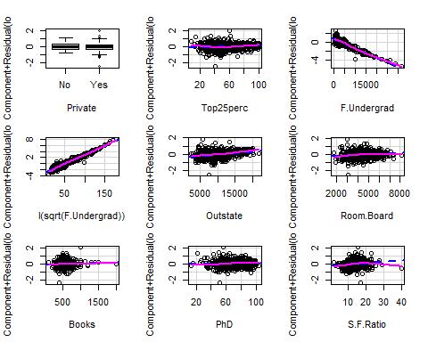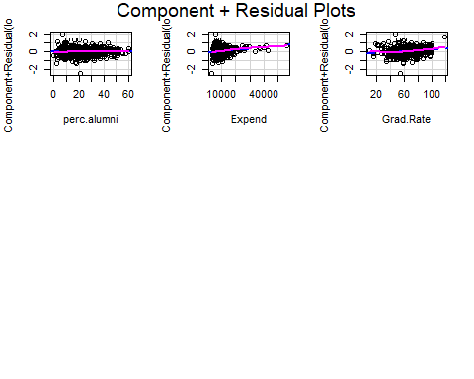

The crPlots presents us with much better results, we see a more linear relationship for F.Undergrad Let’s check this using AIC

AIC(fit2,fit3)

## df AIC  
## fit2 13 1025.5207  
## fit3 14 684.6197

The AIC value goes from 1025 to 684, the transformation results in a much better model!

Let’s build on this model and perform a quadratic transformation on the S.F.Ratio (see crPlot for non linear relationship).

fit4 <- lm(formula = log(Apps) ~ Private + Top25perc + F.Undergrad + I(sqrt(F.Undergrad)) +  
 Outstate + Room.Board + Books + PhD + S.F.Ratio + I(S.F.Ratio^2) + perc.alumni +   
 Expend + Grad.Rate, data = college_statistics_est)  
summary(fit4)

##   
## Call:  
## lm(formula = log(Apps) ~ Private + Top25perc + F.Undergrad +   
## I(sqrt(F.Undergrad)) + Outstate + Room.Board + Books + PhD +   
## S.F.Ratio + I(S.F.Ratio^2) + perc.alumni + Expend + Grad.Rate,   
## data = college_statistics_est)  
##   
## Residuals:  
## Min 1Q Median 3Q Max   
## -2.40208 -0.25394 0.00937 0.26862 1.99871   
##   
## Coefficients:  
## Estimate Std. Error t value Pr(>|t|)   
## (Intercept) 2.909e+00 2.308e-01 12.601 < 2e-16 ***  
## PrivateYes -4.553e-02 7.007e-02 -0.650 0.516060   
## Top25perc 2.463e-03 1.223e-03 2.015 0.044375 *   
## F.Undergrad -2.087e-04 1.607e-05 -12.990 < 2e-16 ***  
## I(sqrt(F.Undergrad)) 5.912e-02 2.773e-03 21.323 < 2e-16 ***  
## Outstate 3.547e-05 8.356e-06 4.245 2.54e-05 ***  
## Room.Board 5.735e-05 2.090e-05 2.744 0.006255 **   
## Books 1.572e-04 1.134e-04 1.386 0.166328   
## PhD 4.130e-04 1.492e-03 0.277 0.782047   
## S.F.Ratio 9.064e-02 2.050e-02 4.421 1.17e-05 ***  
## I(S.F.Ratio^2) -2.172e-03 5.752e-04 -3.776 0.000176 ***  
## perc.alumni 2.506e-04 1.881e-03 0.133 0.894052   
## Expend 2.343e-05 5.588e-06 4.193 3.18e-05 ***  
## Grad.Rate 4.664e-03 1.337e-03 3.489 0.000521 ***  
## ---  
## Signif. codes: 0 '***' 0.001 '**' 0.01 '*' 0.05 '.' 0.1 ' ' 1  
##   
## Residual standard error: 0.4181 on 586 degrees of freedom  
## Multiple R-squared: 0.8426, Adjusted R-squared: 0.8392   
## F-statistic: 241.4 on 13 and 586 DF, p-value: < 2.2e-16

crPlots(fit4)

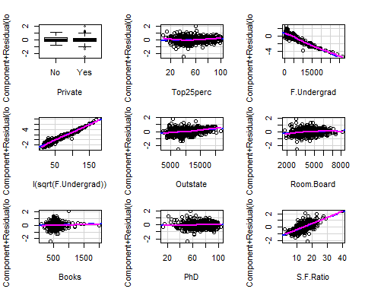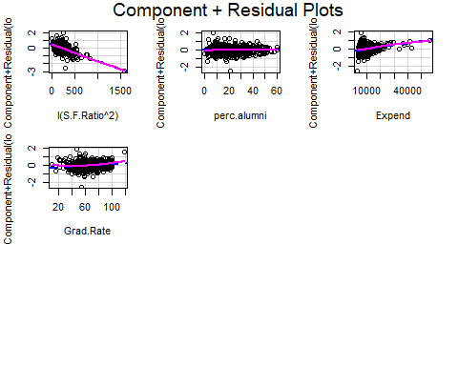

AIC(fit3,fit4)

## df AIC  
## fit3 14 684.6197  
## fit4 15 672.1987

For the sake of keeping this report brief, I’m not going to show the crPlots for each of the transformation. The crPlot of S.F.Ratio is more linear and when we look at the AIC, we can see a slight decrease. The model is improving. Let’s continue:

Next, we perform a quadratic transformation on ‘Grad.Rate’.

fit5 <- lm(formula = log(Apps) ~ Private + Top25perc + F.Undergrad + I(sqrt(F.Undergrad)) +  
 Outstate + Room.Board + Books + PhD + S.F.Ratio + I(S.F.Ratio^2) + perc.alumni +   
 Expend + Grad.Rate+ I(sqrt(Grad.Rate)), data = college_statistics_est)  
  
summary(fit5)

##   
## Call:  
## lm(formula = log(Apps) ~ Private + Top25perc + F.Undergrad +   
## I(sqrt(F.Undergrad)) + Outstate + Room.Board + Books + PhD +   
## S.F.Ratio + I(S.F.Ratio^2) + perc.alumni + Expend + Grad.Rate +   
## I(sqrt(Grad.Rate)), data = college_statistics_est)  
##   
## Residuals:  
## Min 1Q Median 3Q Max   
## -2.36646 -0.25131 0.01409 0.26443 2.01728   
##   
## Coefficients:  
## Estimate Std. Error t value Pr(>|t|)   
## (Intercept) 4.983e+00 5.567e-01 8.951 < 2e-16 ***  
## PrivateYes -4.827e-02 6.916e-02 -0.698 0.485474   
## Top25perc 2.277e-03 1.207e-03 1.886 0.059770 .   
## F.Undergrad -2.040e-04 1.590e-05 -12.828 < 2e-16 ***  
## I(sqrt(F.Undergrad)) 5.847e-02 2.741e-03 21.333 < 2e-16 ***  
## Outstate 3.597e-05 8.247e-06 4.362 1.53e-05 ***  
## Room.Board 5.654e-05 2.063e-05 2.741 0.006305 **   
## Books 1.450e-04 1.120e-04 1.295 0.195815   
## PhD 7.807e-04 1.475e-03 0.529 0.596849   
## S.F.Ratio 9.326e-02 2.024e-02 4.607 5.02e-06 ***  
## I(S.F.Ratio^2) -2.244e-03 5.679e-04 -3.951 8.72e-05 ***  
## perc.alumni -9.288e-05 1.858e-03 -0.050 0.960152   
## Expend 2.159e-05 5.533e-06 3.902 0.000106 ***  
## Grad.Rate 4.036e-02 8.841e-03 4.566 6.07e-06 ***  
## I(sqrt(Grad.Rate)) -5.492e-01 1.345e-01 -4.084 5.05e-05 ***  
## ---  
## Signif. codes: 0 '***' 0.001 '**' 0.01 '*' 0.05 '.' 0.1 ' ' 1  
##   
## Residual standard error: 0.4126 on 585 degrees of freedom  
## Multiple R-squared: 0.847, Adjusted R-squared: 0.8433   
## F-statistic: 231.3 on 14 and 585 DF, p-value: < 2.2e-16

crPlots(fit5)

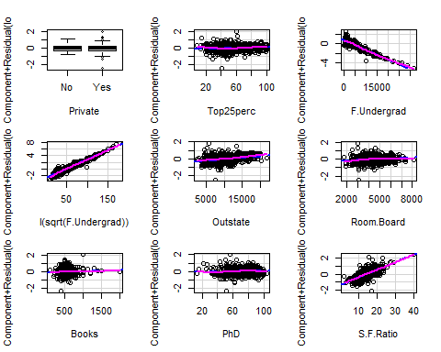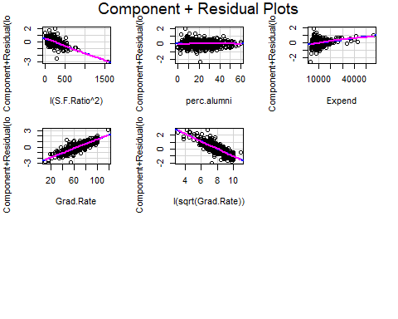

AIC(fit4,fit5)

## df AIC  
## fit4 15 672.1987  
## fit5 16 657.3329

Again, the model goes from an AIC of 672 to 657, a slight improvement. At this point I’m content with the model, more transformation will marginally decrease the AIC and thus I am moving on to the next question.

4 (j) Hoe interpreteer je de coefficienten in het model dat je uiteindelijk hebt gevonden? Wees hierbij heel precies. Welke factoren zijn uiteindelijk het meest van belang?

Because we did a log transformation on ‘Apps’ in this model, we cannot directly interpret the coefficients. What this means is; if the variable (x) increases by 1 the number of ‘Apps’ increases approximately by 100*coefficient %.

The most important variables are as follows: Grad.Rate, S.F.Ratio, F.Undergrad, Outstate and Expend.

4 (k) Gebruik het uiteindelijke model om voorspellingen te maken voor de waarnemingen in de estimation en de test sample.

We use the predict function to make predictions on the test and estimation sets. Exp() is used on these predictions to get the real number of Apps, instead of the log values.

college_statistics_test$predict <- exp(predict(fit5, newdata = college_statistics_test))  
college_statistics_est$predict <- exp(predict(fit5, newdata = college_statistics_est))

4 (l) Vergelijk de voorspelkracht (mbv. mean squared error) van het model op de estimation sample met die op de test sample. Wat concludeer je?

First let’s calculate the mean squared error of both predictions.

test_MSE <- mean((college_statistics_test$Apps - college_statistics_test$predict)^2)  
est_MSE <- mean((college_statistics_est$Apps - college_statistics_est$predict)^2)

The MSE for the test set is 8.509.323, for the estimation set it’s 1.849.956. The model obviously has more explanatory power for the data it was built on. Outside of this sample this power decreases.

## 5. In dit onderdeel voer je een ANOVA analyse uit op de relatie tussen de student faculty ratio en het percentage studenten uit de top 25% van de high school. Volg de volgende stappen:

5 (a) Maak een factor met drie levels op basis van de variabele Top25perc. De levels zijn: laag (minder dan 20%)/midden/hoog (meer dan 40%)

The code below creates a categorical variable from conditions, in the last line this variable is converted to a factor.

college_statistics$catTop25perc[as.numeric(college_statistics$Top25perc)<20]="laag"  
college_statistics$catTop25perc[as.numeric(college_statistics$Top25perc)>=20 & as.numeric(college_statistics$Top25perc)<=40]="midden"  
college_statistics$catTop25perc[as.numeric(college_statistics$Top25perc)>40]="hoog"  
college_statistics$catTop25perc <- as.factor(college_statistics$catTop25perc)

5 (b) Voer de ANOVA analyse uit en geef je conclusie(s). Presenteer de ANOVAresultaten zowel numeriek als grafisch.

First, we do a One-way ANOVA with catTop25perc on S.F.Ratio

aov1 <- aov(S.F.Ratio~catTop25perc, data=college_statistics)  
summary(aov1)

## Df Sum Sq Mean Sq F value Pr(>F)   
## catTop25perc 2 533 266.40 17.74 2.94e-08 ***  
## Residuals 774 11626 15.02   
## ---  
## Signif. codes: 0 '***' 0.001 '**' 0.01 '*' 0.05 '.' 0.1 ' ' 1

H0 : The mean of the dependent variable is the same across all groups We can reject the null hypothesis (p-value < 0.05), thus there are significant differences between groups.

Some visualizations of the results.

TukeyHSD(aov1)

## Tukey multiple comparisons of means  
## 95% family-wise confidence level  
##   
## Fit: aov(formula = S.F.Ratio ~ catTop25perc, data = college_statistics)  
##   
## $catTop25perc  
## diff lwr upr p adj  
## laag-hoog 2.7520788 -0.01757942 5.521737 0.0519049  
## midden-hoog 1.8565738 1.08101717 2.632130 0.0000001  
## midden-laag -0.8955051 -3.72213044 1.931120 0.7373750

plot(TukeyHSD(aov1))

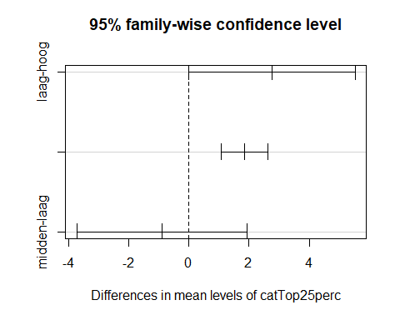

5 (c) Onderzoek of er outliers zijn. Pas de analyse aan als dat nodig is.

outlierTest(aov1)

## rstudent unadjusted p-value Bonferroni p  
## Indiana Wesleyan University 6.965011 7.0276e-12 5.4605e-09

We find an outlier for Indiana Wesleyan University. Let’s drop this observation and try again.

college_statistics_outlier <- college_statistics[rownames(college_statistics) != 'Indiana Wesleyan University',]

Run the model again.

aov2 <- aov(S.F.Ratio~catTop25perc, data=college_statistics_outlier)  
summary(aov2)

## Df Sum Sq Mean Sq F value Pr(>F)   
## catTop25perc 2 557 278.73 19.7 4.54e-09 ***  
## Residuals 773 10939 14.15   
## ---  
## Signif. codes: 0 '***' 0.001 '**' 0.01 '*' 0.05 '.' 0.1 ' ' 1

H0 : The mean of the dependent variable is the same across all groups Again, We can reject the null hypothesis (p-value < 0.05), thus there are significant differences between groups.

Some visuals:

TukeyHSD(aov2)

## Tukey multiple comparisons of means  
## 95% family-wise confidence level  
##   
## Fit: aov(formula = S.F.Ratio ~ catTop25perc, data = college_statistics_outlier)  
##   
## $catTop25perc  
## diff lwr upr p adj  
## laag-hoog 2.7968298 0.1084056 5.485254 0.0392212  
## midden-hoog 1.9013248 1.1483759 2.654274 0.0000000  
## midden-laag -0.8955051 -3.6391823 1.848172 0.7237357

plot(TukeyHSD(aov2))

